**PIZZA SALES SQL QUERIES**

PIZZA SALES QUESTIONS:

KPI’S Requirement

1)Total Revenue: The sum of the total price of all pizza orders

* select sum(total_price) as total_price from pizza;

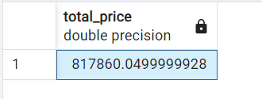

2)average Order Value: The average amount spent per order,calculated by dividing the total revenue by the total number of orders

* select sum(total_price)/count(distinct order_id) as total_revenue from pizza;

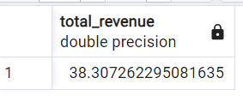

3)Total Pizzas Sold: The sum of the qualities of all pizza sold

* select sum(quantity) as total_pizza_sold from pizza;

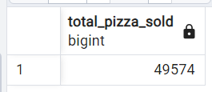

4)Total Orders: The total number of orders placed

* select count(distinct order_id) as total_orders from pizza;

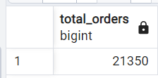

5)Average Pizzas For Order: The average number of pizzas sold per order, calculated by dividing the total number of pizzas sold by the total number of orders.

* SELECT CAST(SUM(quantity) AS DECIMAL(10,2)) / CAST(COUNT(DISTINCT order_id) AS DECIMAL(10,2)) AS avg_pizza FROM pizza;

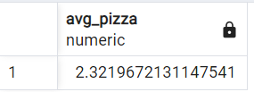

1. **Daily Trend for Total Orders**

* SELECT to_char(order_date, 'Day') AS day, COUNT(DISTINCT order_id) AS total_order FROM pizza GROUP BY to_char(order_date, 'Day');

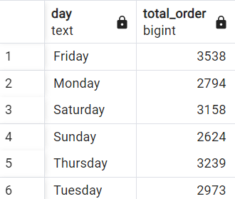

1. **Monthly Trend for Orders**

select to_char(order_date,'month') as date, count(distinct order_id) as order from pizza

group by date;

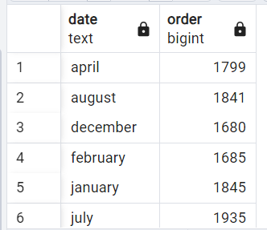

1. **% of Sales by Pizza Category**

select pizza_category,sum(total_price)*100/

(select sum(total_price) from pizza) as percentage_of_sales_by_category

from pizza group by pizza_category;

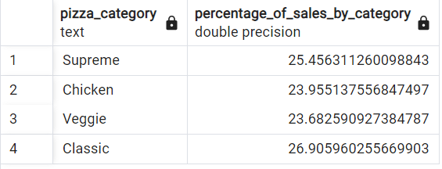

1. **% of Sales by Pizza Size**select pizza_size,sum(total_price)*100/

(select sum(total_price) from pizza) as percentage_of_sales_by_category

from pizza group by pizza_size;

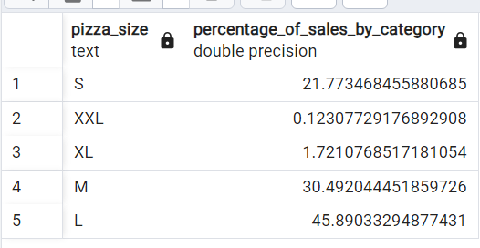

* **TOP AND BOTTOM**

1. Top 5 best sellers by revenue ,total quantity and total orders.

* select pizza_name,sum(total_price) as revenue from pizza

group by pizza_name order by revenue desc limit 5;

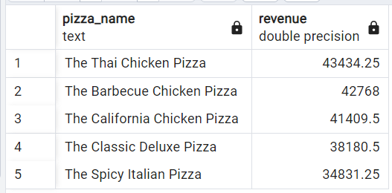

1. Bottom 5 pizza by revenue

* select pizza_name,sum(total_price) as revenue from pizza

group by pizza_name order by revenue limit 5;

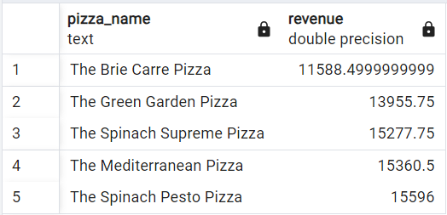

1. Top 5 pizza by quantity

* select pizza_name,sum(quantity) as top_quantity from pizza

group by pizza_name order by top_quantity desc limit 5;

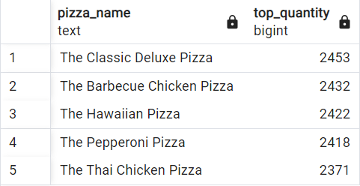

1. Bottom 5 pizza by quantity

* select pizza_name,sum(quantity) as top_quantity from pizza

group by pizza_name order by top_quantity limit 5;

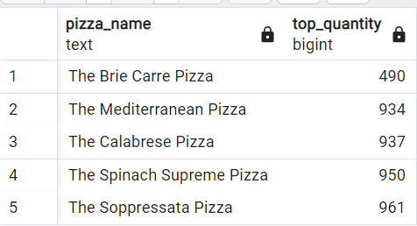

1. Top 5 pizza by total_orders

* select pizza_name, count(distinct order_id) as total_orders

from pizza group by pizza_name order by total_orders desc limit 5;

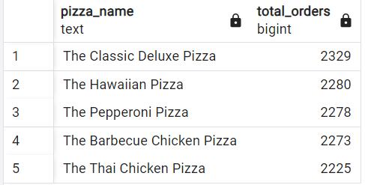

1. Bootom 5 pizza by total orders

* select pizza_name, count(distinct order_id) as total_orders

from pizza group by pizza_name order by total_orders limit 5;

